***Technology management***

***Summer semester***

***Assignment 4***

***Group assignment***

Vaania asif 221438858

Muhmmad ahmad 231467550

Muhammad Mustafa 231469864

Created a domain named: “nothingtaken”

Then created 2 projects on Jira Service Management, and Jira Software:

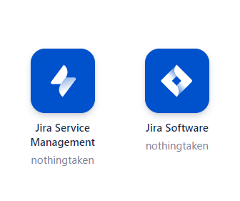

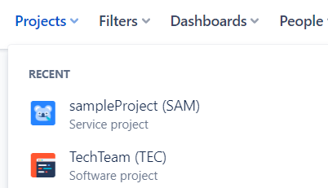

Jira Software Project:

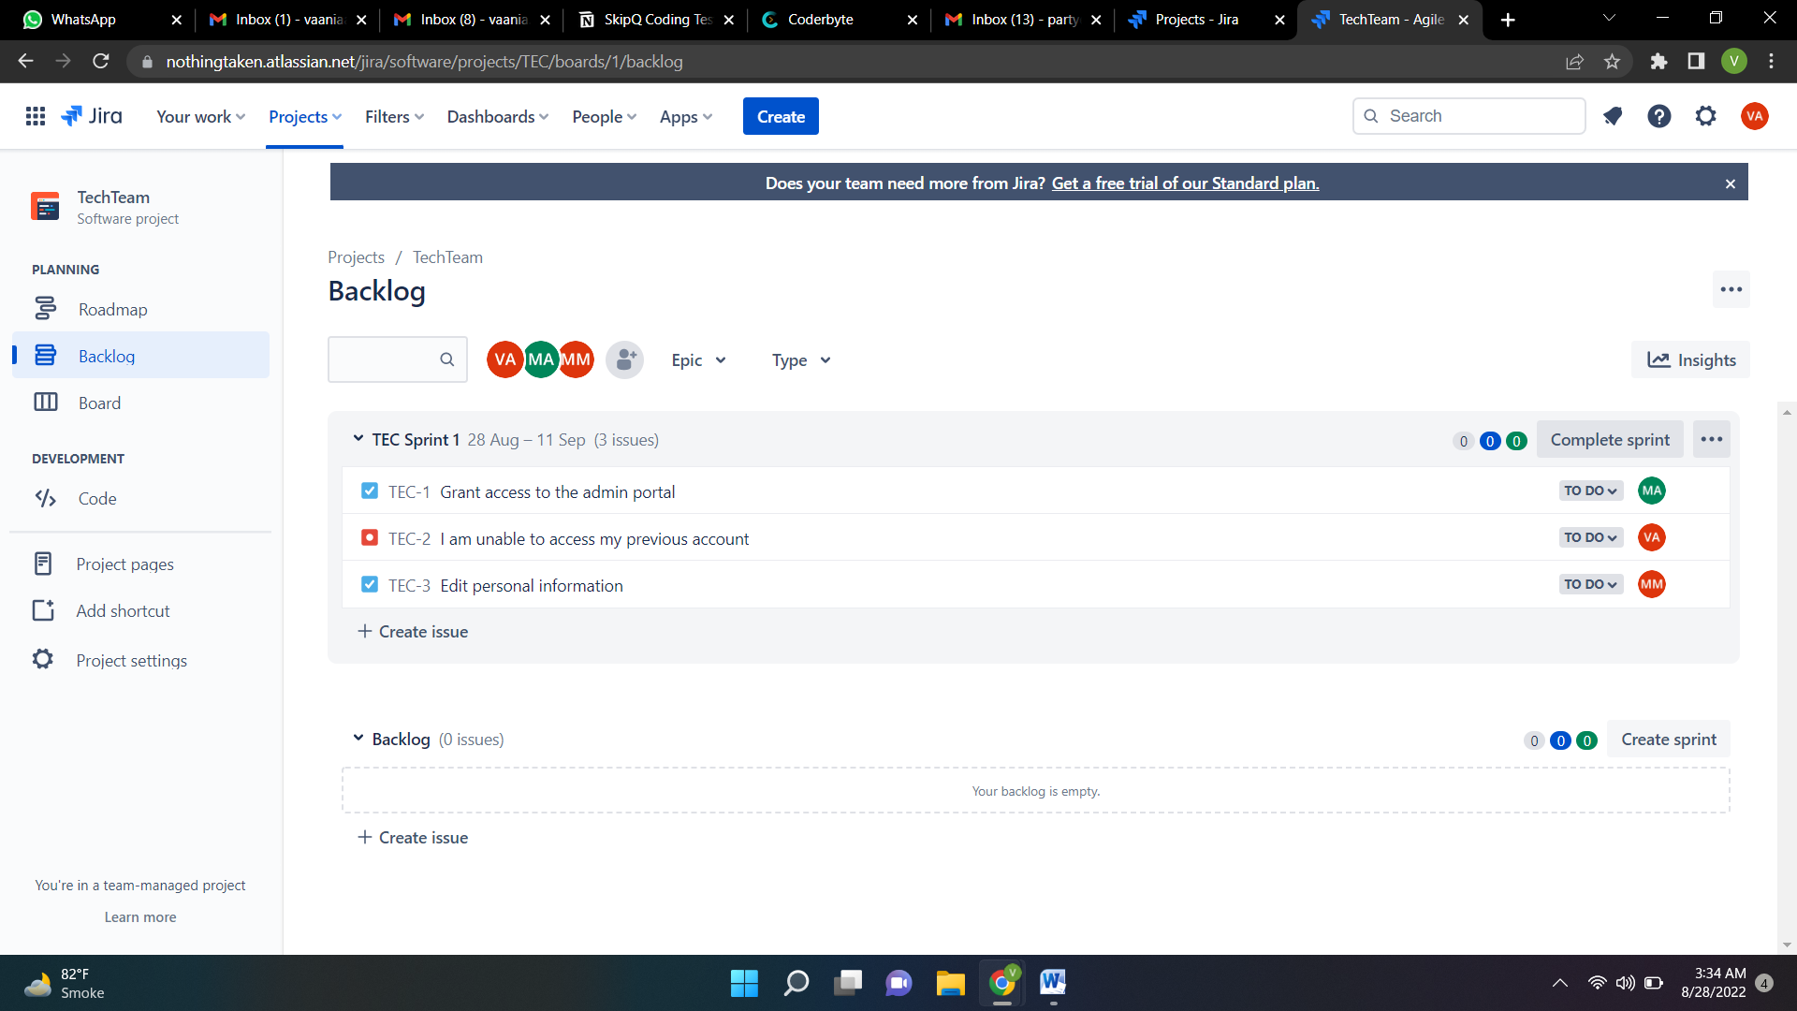

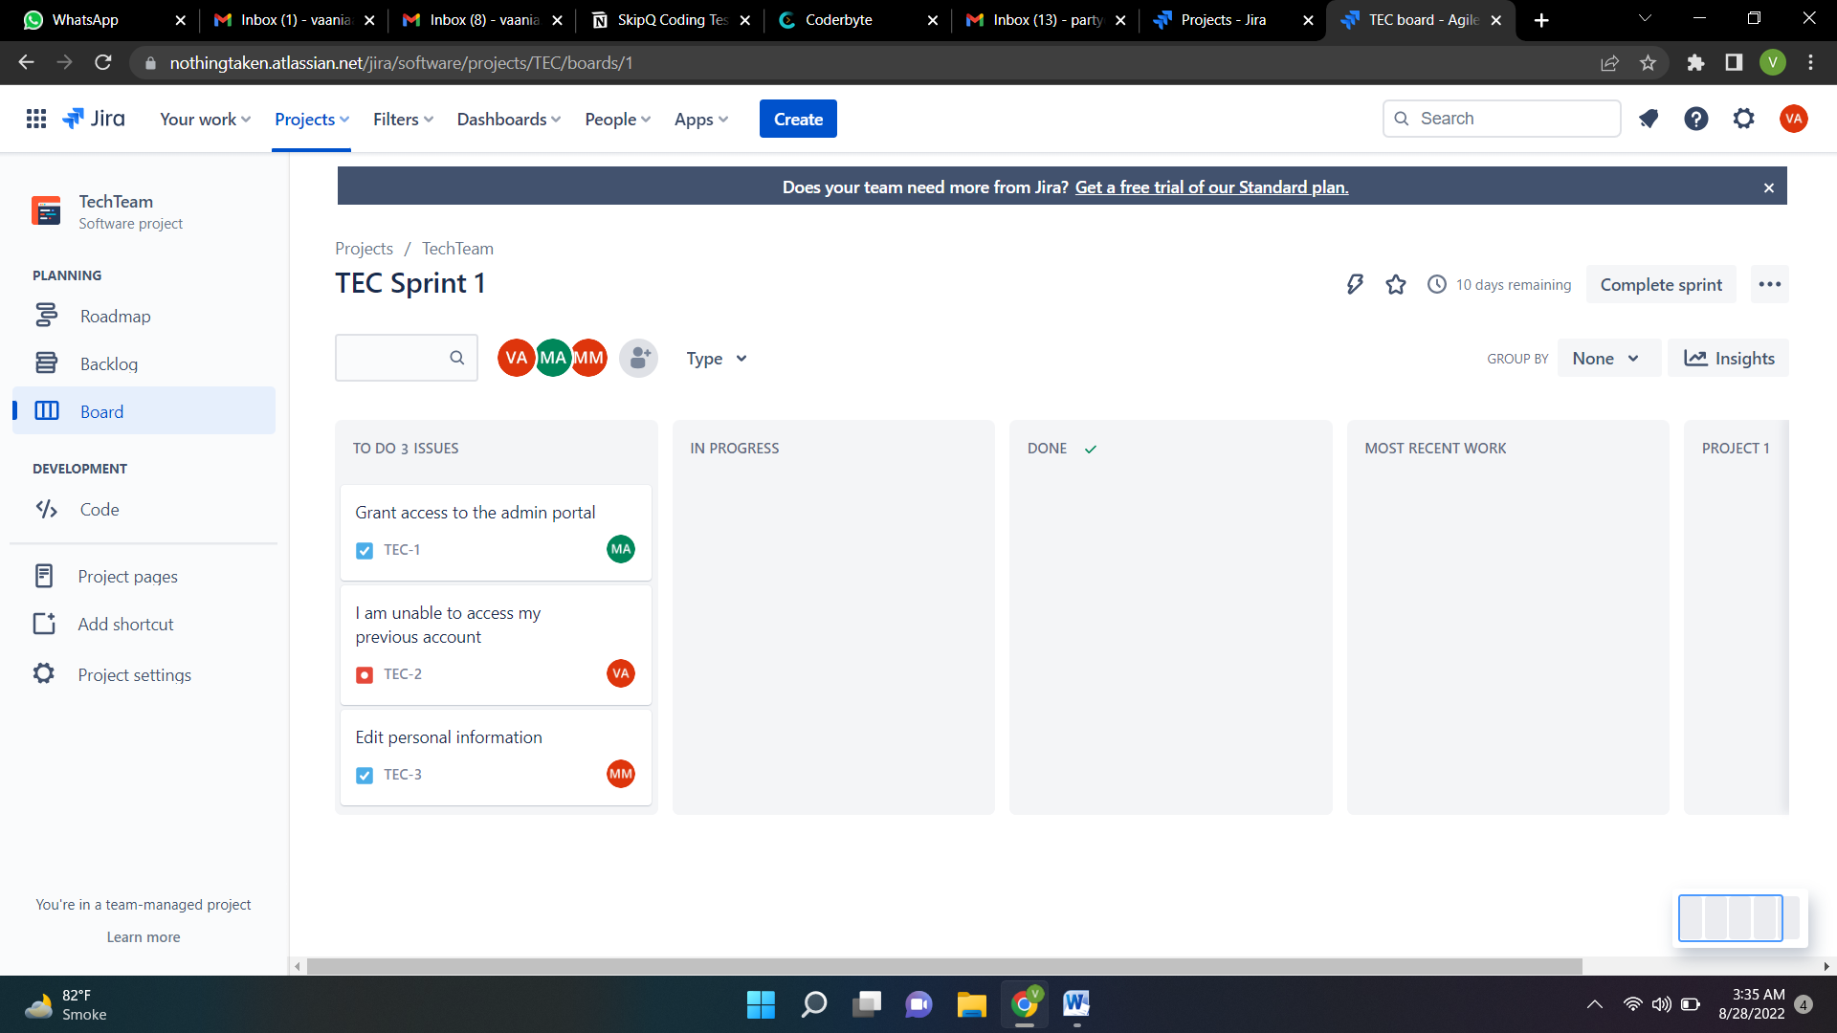

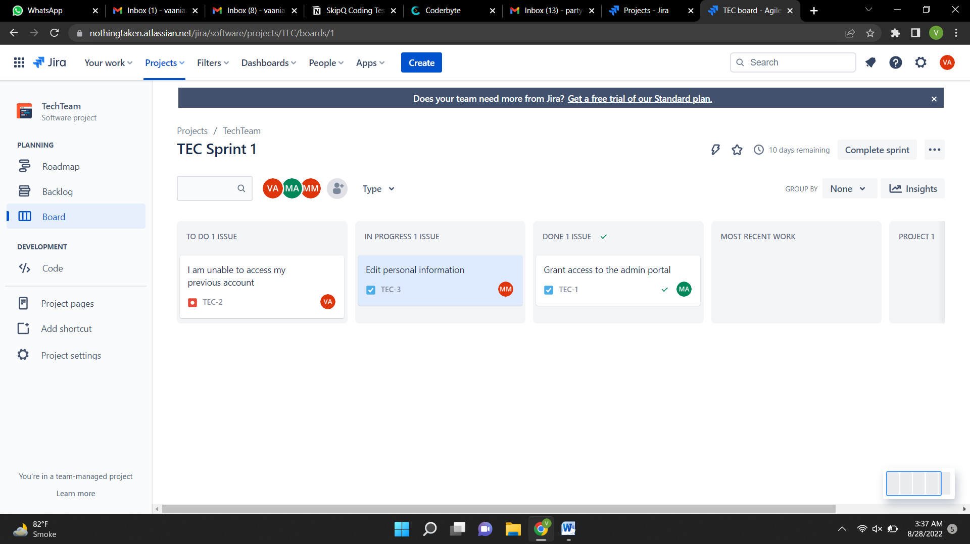

Jira Service Management Project:

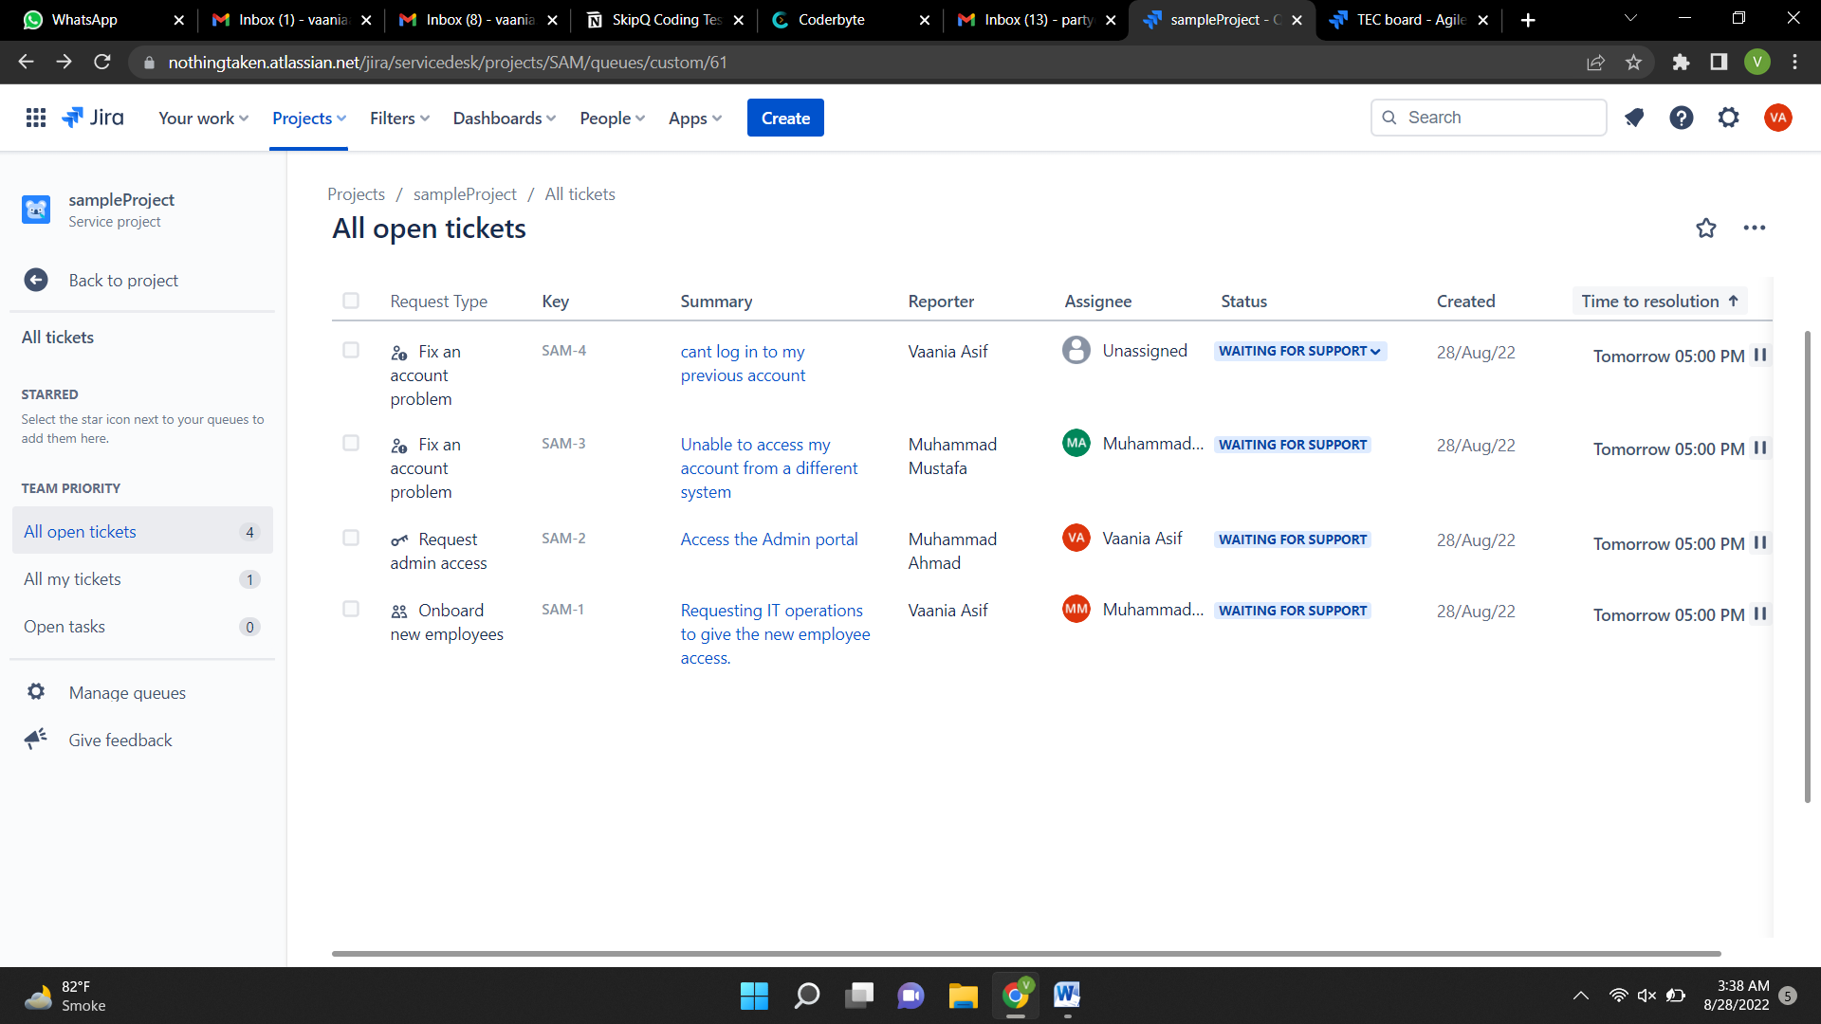

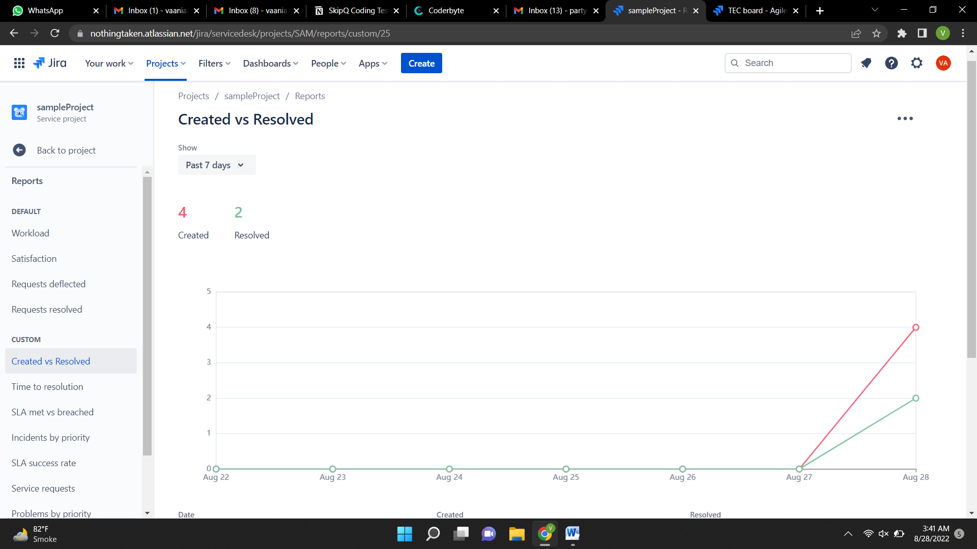

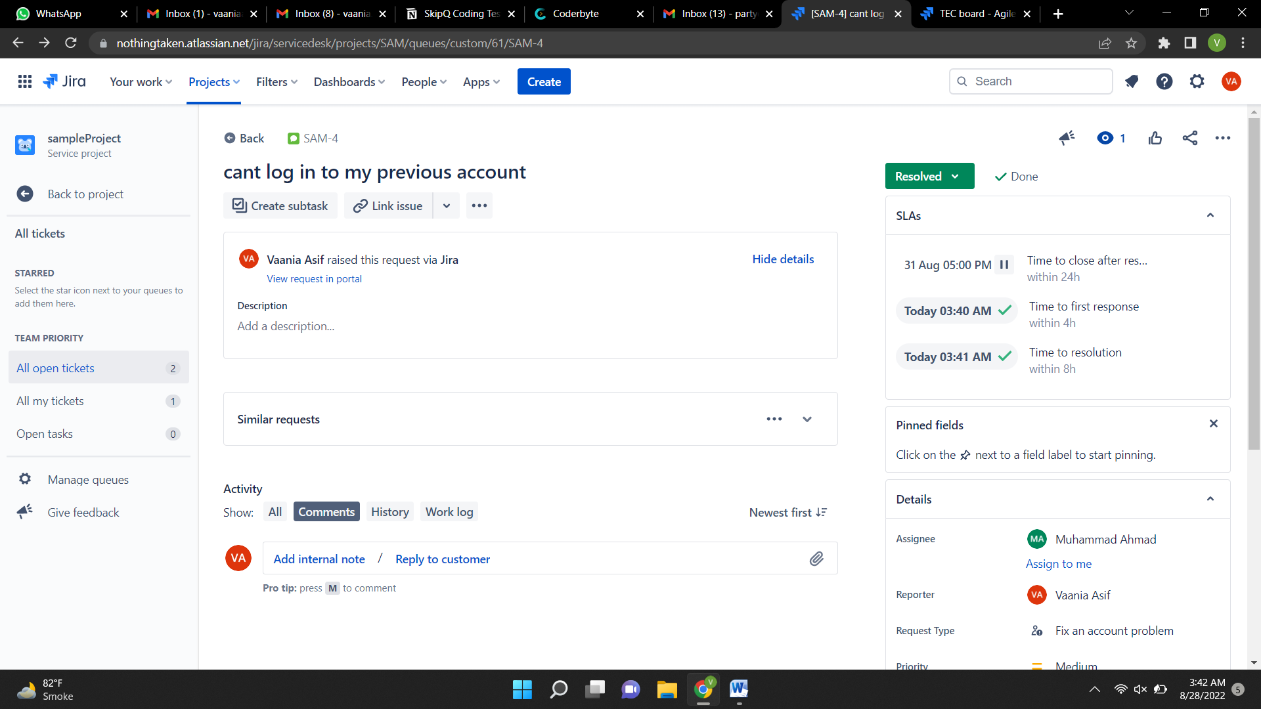

Contributions of team:

Vaania Asif: Created and assigned issues and tickets.  
Muhammad Ahmad: Created, modified and customized Jira Service Management tool according to the requirement of this assignment.

Muhammad Mustafa: Created, modified and customized Jira Software tool according to the requirement of this assignment.

The tickets were resolved by all three members where necessary.